Connect Chance Report – noughts & crosses

The premise of the game was two players would choose whether they were noughts or crosses – as normal, however the board would be 4 by 4 rather than 3 by 3 and there was also an element of chance implemented.

The materials needed were just a pen and paper as well as two dice. But a board and counters could also be made for a more permanent version of the game. Overall, if counters were to be used there’d be 16 – 8 of each.

The rules of the game were two players either choose to play as X or O. Then both players must roll the x/o dice each turn to decide which shape they use on the board each turn. The dice roll will determine the column the player has to play in and then they get to choose the row. If there is no space left in the column, the player will miss their turn. The first player with a full row in any direction is deemed the winner.

The game was played by the players deciding whose noughts or crosses and who goes first. On each turn, the players rolled a six-sided die to decide which symbol they played as on their turn. Another die, this time 4-sided, was then rolled to decide their y-coordinate but the player chose the x-coordinate themselves. When the player was given their opponent’s symbol, they tried to sabotage them to stop them from being able to win.

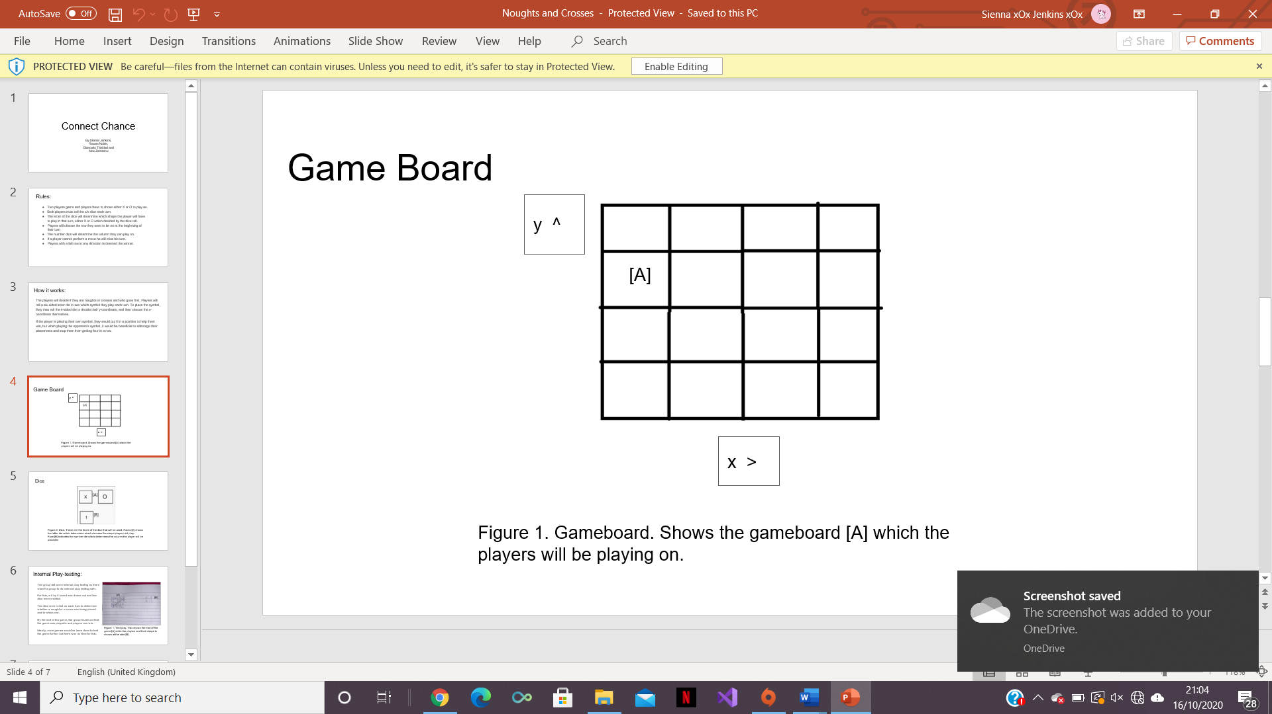

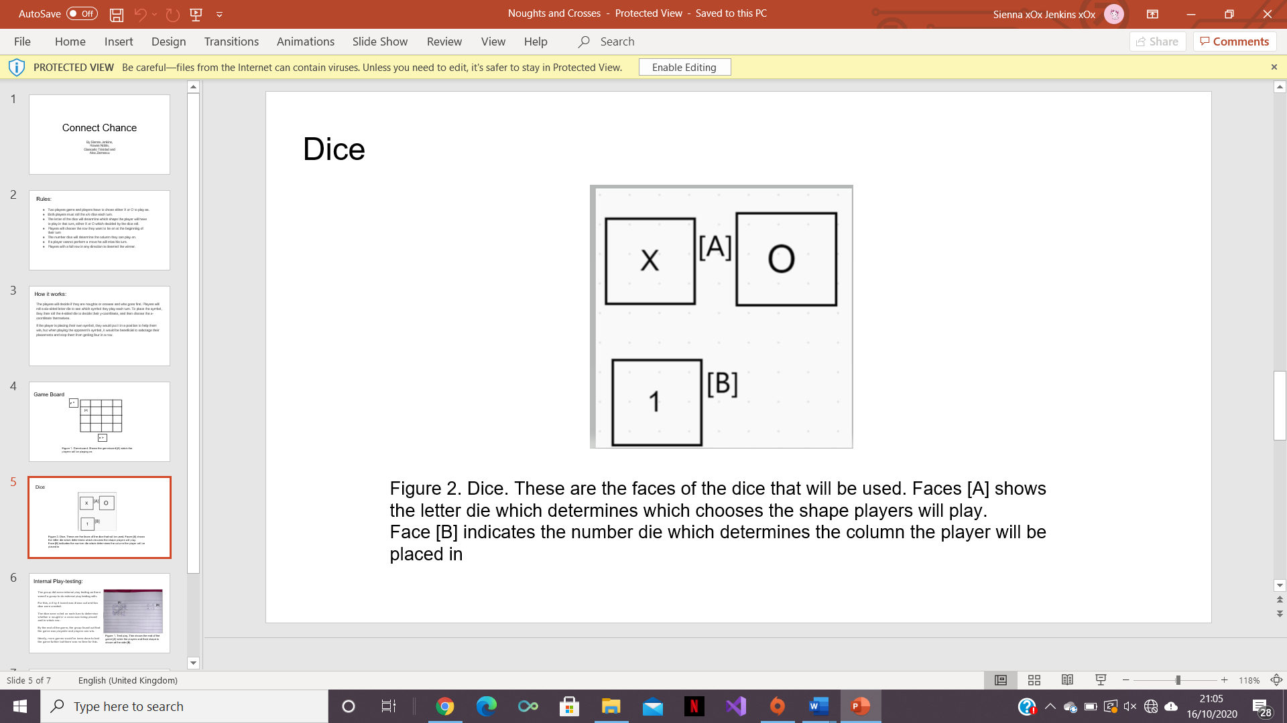

For play testing, the group did some internally, given no groups responded to the request to do external play testing. For this, a 4 by 4 board was drawn out and two dice were created. The dice were rolled on each turn to determine whether a nought or a cross was being placed and in which row. By the end of the game, the group found out that the game was playable, and players can win. Ideally, more games would’ve been done to test the game further but there was no time for this.

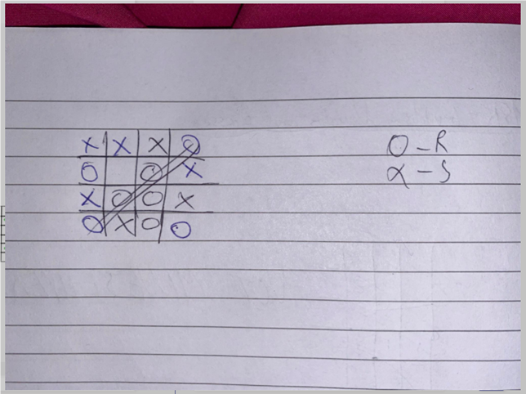

Working as a team was good – it allowed internal play testing to be carried out and it meant all members of the team could look at the ideas of others and see if it had any issues with the functionality.

Next time, it would be good to do external play testing as the internal play testing might’ve been biased as the group came up with the idea and therefore might not have seen as many issues as maybe someone else would’ve.

The game developers and designers:

Sienna Jenkins,

Rowan Noble,

Giancarlo Trinidad and

Alex Zarnescu